{currentDate}

SRP WEST VALLEY

2727 E. Washington Street

Phoenix, AZ 85034-1403

Via SharePoint

SUBJECT: **{projectName}: SRP Plan Submittal**

***{projectAddress} {projectCityStateZip}***

***APN: {apn}***

Dear SRP,

Thank you for assisting us with the preparation of your electric service design. Attached are plans for you to use in the design of your system for this project. Your plan submittal package consists of:

1 copy of the Architectural dimensioned site plan

1 set of improvement plans – water, sewer, paving,

1 grading & drainage

1. set of electrical plans

1 Landscaping Plans

1 AutoCAD and pdf electronic files for base map use

1 completed SRP Checklist and Request for Design form

1 SRP Plan Review Request Form

Sheets ES-1 of the enclosed plans show the preferred SES and transformer locations. Sheet E-4 show the one-line diagram requesting 600amps @ 120/208v.

Please note:

The one-line diagram reflects the meter attached to the transformer. (Sheet E-4)

In addition to using our plans for the new business design, the improvement plans are intended for you to use in completing your conflict check. Please review our improvement plans at this time to determine if there are additional conflicts. Should you determine that there are conflicts, please let us know so that we may anticipate future relocation needs.

**We are ready for the SRP scoping meeting. Please let us know the first available date for the SRP scoping meeting.**

My firm is working as the owner's representative for the {siteLLC} on this project. Please forward all contracts, drawings, and correspondence to my attention at Dry Utility Services. If you need additional information to start your design or if you have any questions, please contact me at 602-224-5085.

Sincerely,

DRY UTILITY SERVICES

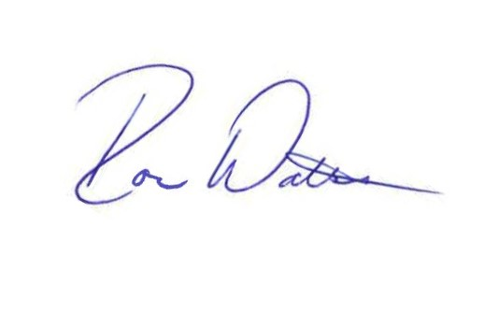

Ron Watson

President

[ronw@dusaz.com](mailto:ronw@dusaz.com)